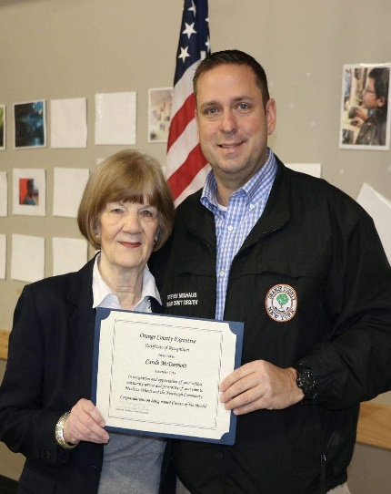
 | Web: www.MealsOnWheelsNewburgh.org/ | Phone: 845-562-3490
 | 2020 TAKE A SWING AT HUNGER!
 | Newburgh Meals on Wheels prepares hot and nutritious meals for elderly or disabled clients, which are delivered by dedicated volunteers. Founded in 1972 by Frederica Warner, we are a registered 501(c)3 charity. Donations are tax-deductible. Please help us with our goal to provide 10 of our neediest clients with free meals for a year!

Platinum “Ace” Sponsor $3,000  Full page program ad, company logo on golf balls and tournament banner  Gold “Eagle” Sponsor $1,000  Half page program ad, signage on 2 holes, recognition on player gift  Silver “Birdie” Sponsor $500  Quarter page program ad, signage on 1 holes and Award Ceremony recognition  Bronze “Par” Sponsor $250  Business card program ad and  signage on 1 hole  MOW “Supporter” $100  Recognition in event program  “Friend” or Raffle Donor $25 +  Program listing | BE A SPONSOR!
 | A $500 Silver “Birdie” donation pays for 6 months of meals for a neighbor in need!
 | 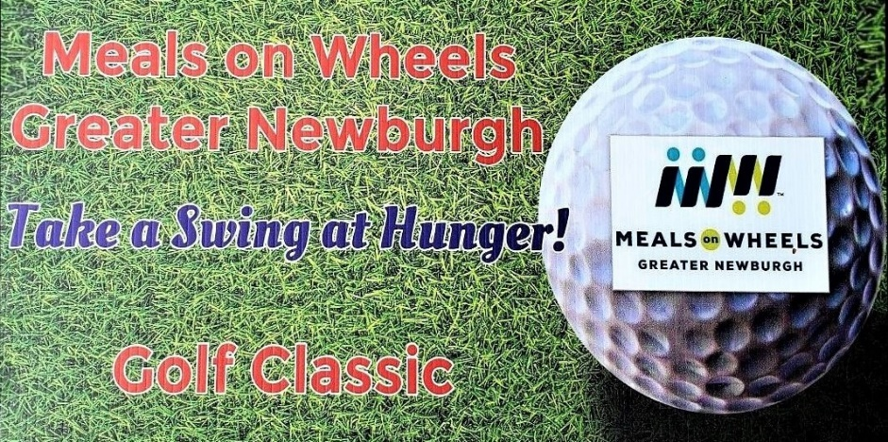
SPONSOR DONATION FORM – SUPPORT MEALS ON WHEELS
Your gift is tax deductible. Please send a business card with your check payable to: Meals on Wheels of Greater Newburgh, PO Box 2615, Newburgh, NY 12550
Donor Name: |  | Email:
Address: |  | Phone:
Sponsorship Level & Donation Amount (please check one)
Platinum “Ace” $3,000 _____ Silver “Birdie” $500_____ MOW “Supporter” $100_____
Gold “Eagle” $1,000 _____ Bronze “Par” $250 _____ MOW “Friend” $25+ _____

