Take a Swing At Hunger
Golf Classic
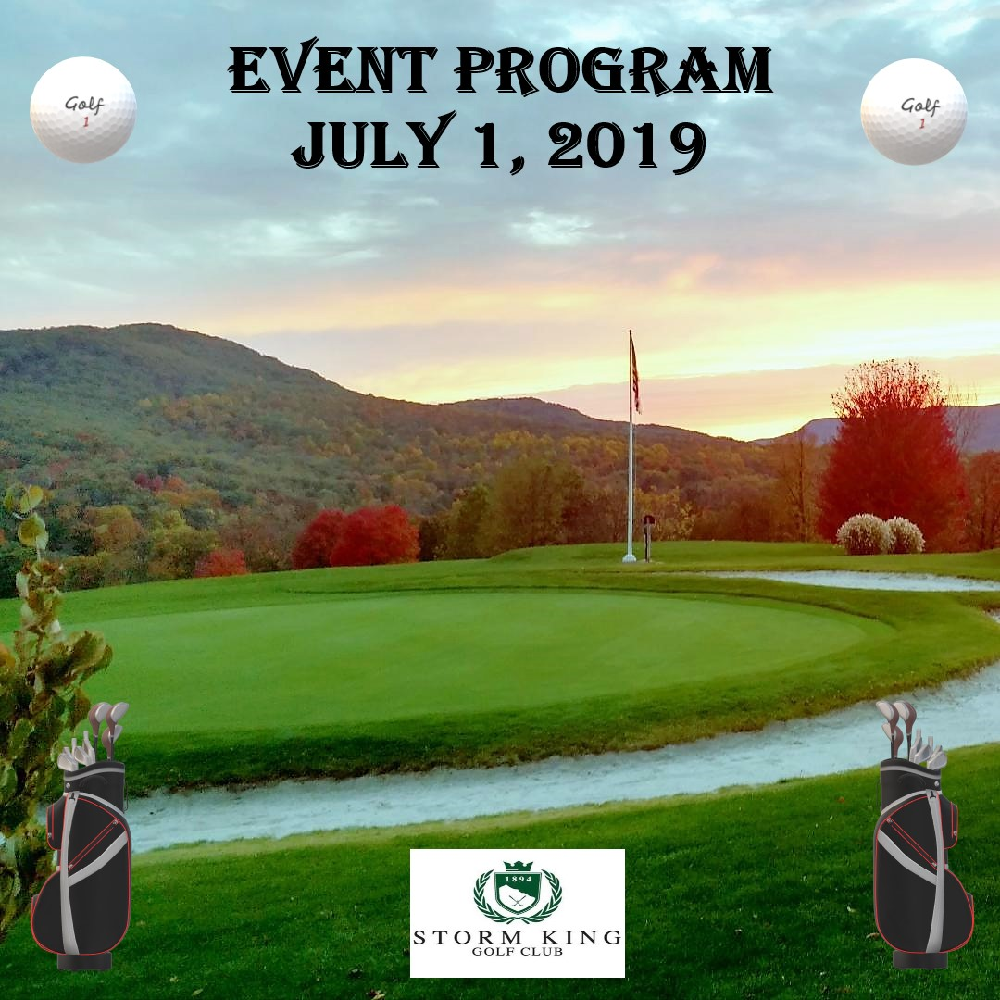
Storm King Golf Club
18 Ridge Road, Cornwall, New York 12518
Meals on Wheels of Newburgh Team
Staff & Board of Directors
Founder
Frederica Warner, 1917-2019
Staff
Robin Bello, Executive Director
Mary “Mae” Dorsey, Head Cook
Clara Green, Assistant Cook
Diann Burks, Assistant Cook
Kim Riley, Assistant Cook
Barbara Wimmer, Assistant Cook
Nancy Hines, Admin Assistant
Board of Directors & Officers
Carole S. McDermott, President
Darlene Price, 1st Vice President & Secretary
Wilbur Higgins, 2nd Vice President
James M. Corsetti, Treasurer
Board of Directors

Faye Canfield
John DeLessio
Anthony DeRienzo
Joseph S. Dirago
Sue Favoino
Philip Lawry
Linda Lewis-Burger
Richard Mayfield
Betsy McCurdy
Mona Sodano
Joseph Rones
Bianca Rostran
Martin Sheffield
Richard Truocchio
Charles Venuto

Welcome Message
Meals on Wheels of Greater Newburgh, Inc. welcomes you to its inaugural charity golf tournament, “Take a Swing at Hunger”, at Storm King Country Club and Tavern, Cornwall, New York. We have planned a fantastic golf outing, with lots of contests and prizes for the golfers, that will be enjoyable for all!

Thank you for attending today’s event and your support of our organization. The funds raised from “Take a Swing at Hunger” Golf Classic will help provide hot, nutritious meals for the elderly and disabled in our community. Since 1972, Meals on Wheels of Greater Newburgh has delivered home-cooked meals to the elderly, the disabled and others with special needs. With the support of over 100 dedicated volunteers, we have delivered over one-half million meals in the past 46 plus years.

Meals on Wheels of Greater Newburgh is a registered 501(c)3 charity and member of Meals on Wheels America. We do not receive any funding from city, state or federal government sources and depend on contributions from concerned citizens and businesses to help us provide meals to those in need.

With the support of our generous tournament sponsors, the golfer’s participation today, as well as the funds raised from our raffle and silent auction, it will help us to maintain our mission of helping those in need. Funds raised from today’s event will be used to provide meals for our neediest clients.

Please support our sponsors who have extended themselves to support us and further the cause of Meals on Wheels of Greater Newburgh.
Yours Sincerely,
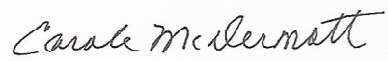
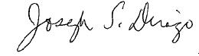

Joe Dirago Carole McDermott
Director President
Take A Swing at Hunger Golf Classic Board of Directors
____________________________________________________________________
Meals on Wheels of Greater Newburgh, Inc.
35 Cerone Place, P.O. Box 2615, Newburgh, NY 12550
www.mealsonwheelsnewburgh.org
Event Schedule
- 8:00 – 9:00 a.m. - Golf Registration
- Continental Breakfast
- 9:00 a.m. - Welcome by Joe Dirago, Golf Classic Director
- Course Instructions and Event Rules by
Brendan Murcko, Storm King Golf Club
- Best Ball Scramble Golf – Shotgun Start
- 2:00 p.m. - Welcome by Carole McDermott, President,
Meals on Wheels Board of Directors
- Golf Awards Ceremony, Brendan Murcko and Joe Dirago
- 2:15 p.m. - Barbeque Lunch at Storm King Tavern
- 3:00 p.m. - Raffle and Silent Auction
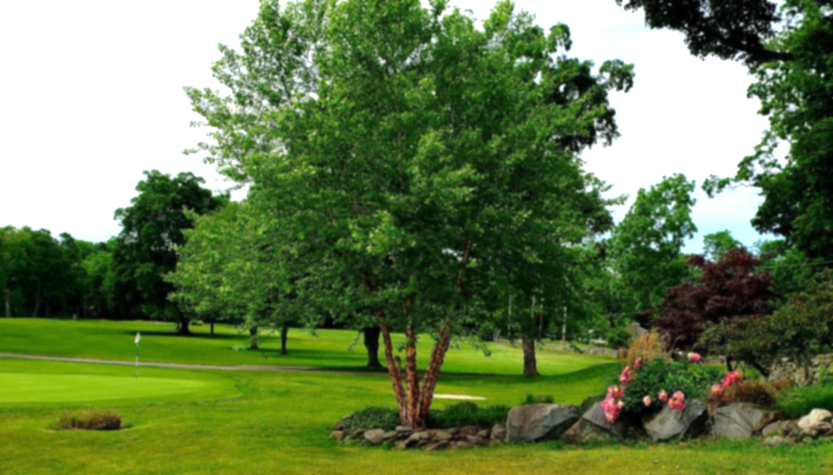
Golf Classic Prizes and Contests

- Best Team Foursome Scores
- Longest Drive Men – Hole #6
- Longest Drive Ladies – Hole #6
- Longest Putt – Hole #9
- Closest to Pin – Hole #12
- Closest to Pin Hole - #17
Course Refreshments
The golfer’s registration bag includes a bottled water, snack bars and other goodies for your enjoyment. Complimentary water is available near the Tee Boxes of Holes #6 and #15.
Storm King Tavern will have a roving Bar Cart (cash) from 11 am to 1:30 pm, with soft drinks and beer.
Barbeque luncheon Menu
Storm King Tavern

- BBQ and Grilled Chicken

Sausage and Peppers
- Macaroni and Cheese
- Corn on the Cob
- Coleslaw
- Potato Salad
- Corn Bread
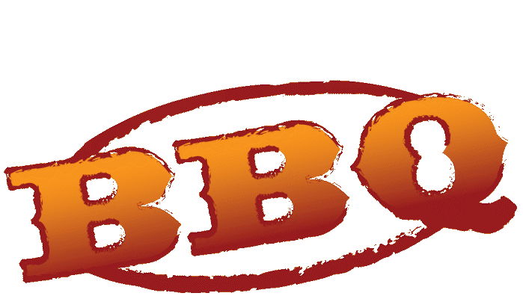
- Soda, Coffee and Tea
- Dessert

Our Tournament Host
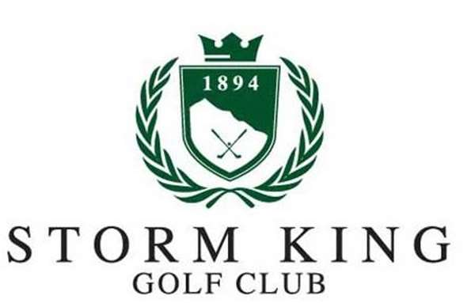  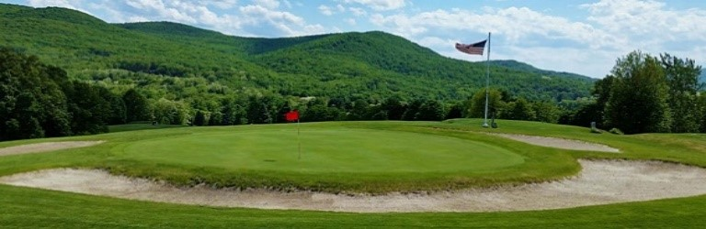 | Storm King Golf Club  18 Ridge Road, Cornwall, New York
 | www.StormKingGolfClub.com | 845-534-3899
 | Founded in 1894, Storm King Golf Club is one of the oldest clubs in America. The historic and challenging course is well maintained with picturesque scenery, providing one of the best golf experiences in the Hudson Valley. Storm King Tavern sits atop the hill and has a beautiful view of the golf course and Black Rock Forest.
Golf Classic Volunteers
A special thank you to the volunteers who assisted with today’s registration, breakfast, golf contests, Foursome Photos, Silent Auction and Prize Raffle.

- Robin Bello
- Faye Canfield
- Linda Dirago
- Martin Sheffield
- Mona Sodano
- Linda Lewis-Burger
- Judy Truocchio
- Rich Truocchio

Prize Raffle
Our incredible Prize Raffle will be held after the Golf Awards Ceremony. Raffle prizes are worth over $1,000! Following are some of the great prizes that will be included in the raffle.
- Hudson Valley Renegades 4 Pack (4 Game Tickets & 4 Hats)
- Greens Fee Passes – Shawangunk CC and Twaalfskill Golf Club
- Lottery Tree Filled with Scratch Off Tickets
- New Paltz Golf Course $50 Gift Certificate
- Gift Baskets Galore – Soaps, Wine & Cheese, Beer and Snack
- Gift Certificates from Local Restaurants and Businesses
- Golf Ball Blitz – Nitro Max, VGolf Icicles & Wilson Ultra
- Drizzle Stick Flex Golf Umbrella
- Coleman Messenger Soft Cooler Bag
Silent Auction
Several valuable donations will be included in our Silent Auction. A minimum bid is required with set increments following. Please bid generously as all donations support Meals on Wheels of Greater Newburgh. Silent Auction winners will be announced after the Prize Raffle. Following are some of the Silent Auction items:
- New York Jets Team Autographed Logo Football
- New York Giants Limited Edition Team Collector’s Football
- The Country Club at Otterkill (4 Greens Fees with Cart)
- Hudson Valley Renegades 4 Pack (4 Game Tickets & 4 Hats)
- Jets versus Giants Preseason Game Tickets (2) with Parking Pass
- John Gould Print of the Newburgh Ferry
Foursome Photos
Capture the experience between Hole #9 and Hole #1, where a Golf Classic Volunteer will take a photo of your Foursome. The golf course with the mountains in the background will make a terrific photo memory.
Golf Classic Sponsors
Meals on Wheels of Greater Newburgh sincerely thanks our sponsors. Their generous donations have made this inaugural “Take a Swing at Hunger” Golf Classic possible. Please support our sponsors!
Gold “Eagle” Sponsor
The William and Elaine Kaplan Family Foundation
The William and Elaine Kaplan Family Private Foundation

Gold “Eagle” Sponsor
GTI Graphic Technology Inc
Silver “Birdie” Sponsors
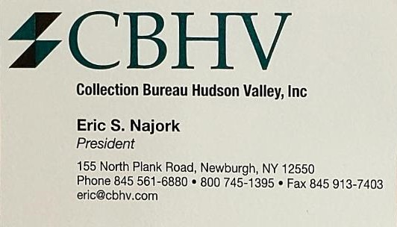 | 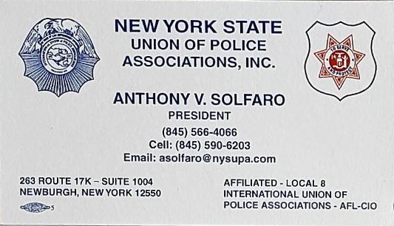
Collection Bureau Hudson Valley Inc | New York State Union of  Police Associations Inc
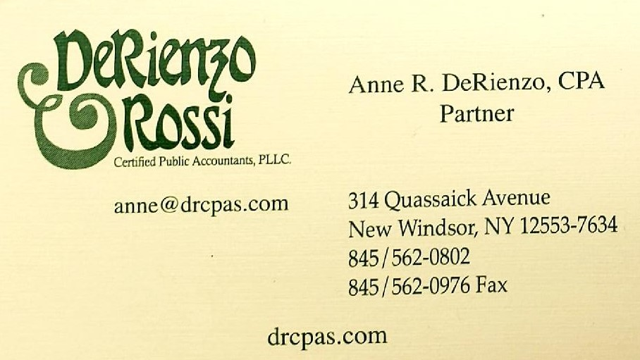 | 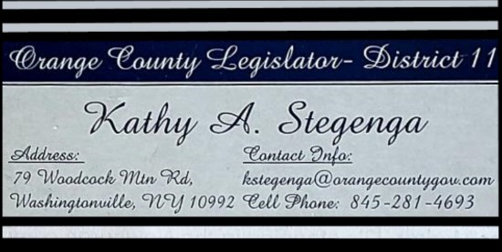
DeRienzo & Rossi  Certified public accountants | Kathy a. Stegenga  Orange County legislator
 | 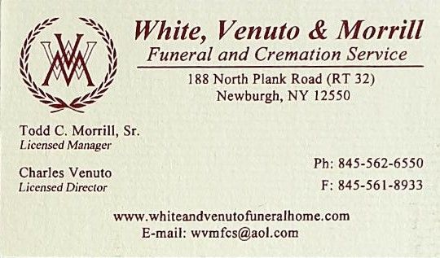
Mobile Life Support Services Inc | White, Venuto & Morrill  Funeral & Cremation Service
Bronze “Par” Sponsors
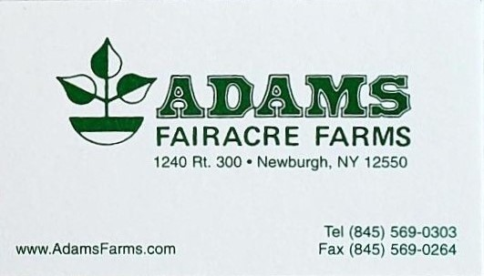 |  | 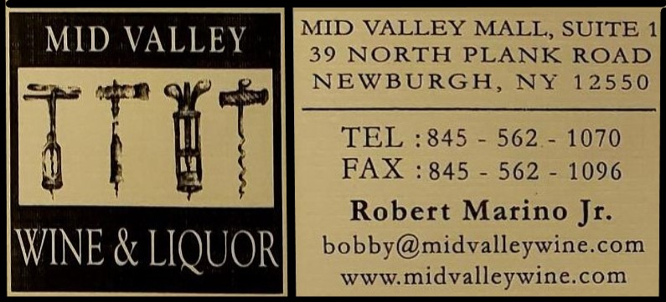
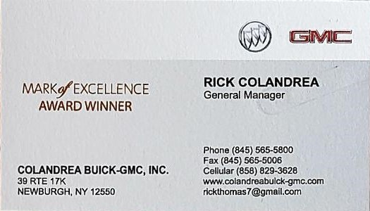 |  | 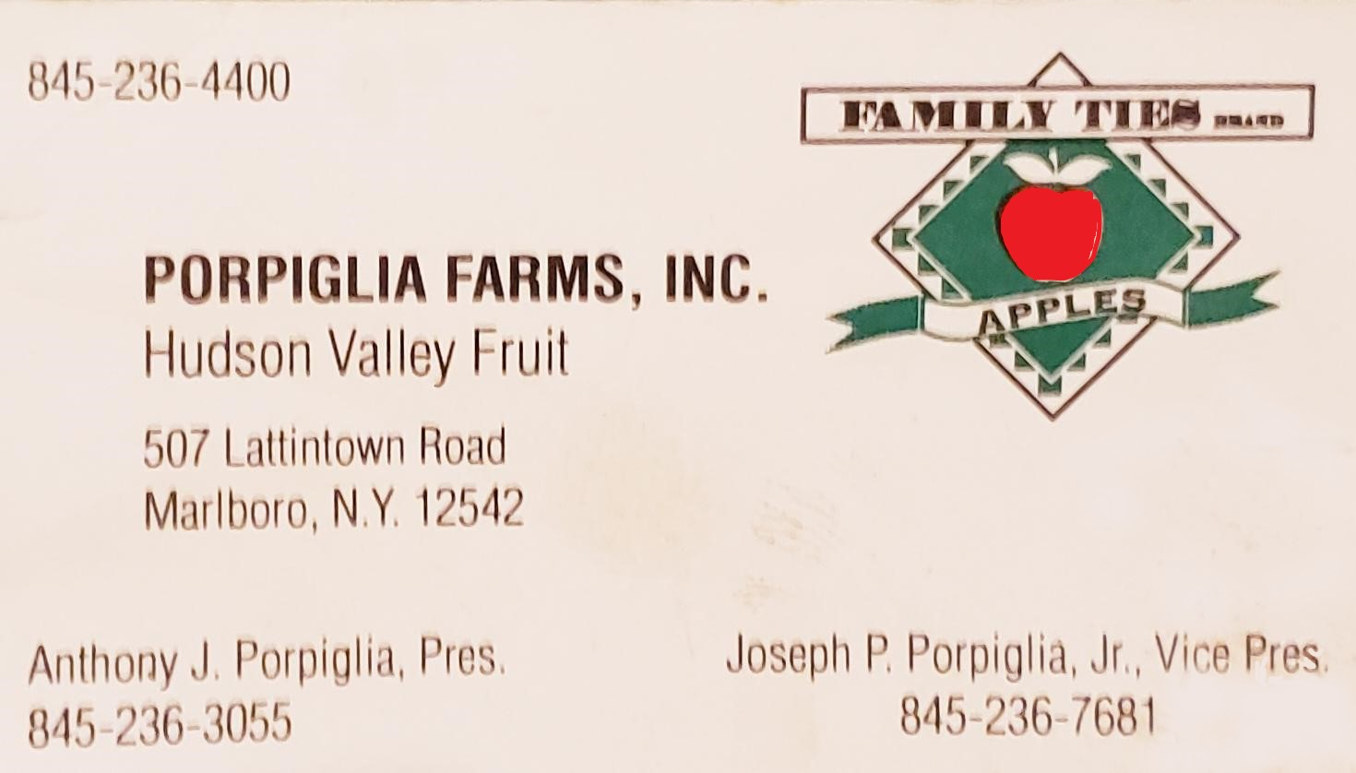
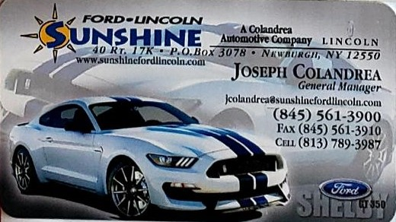 |  | 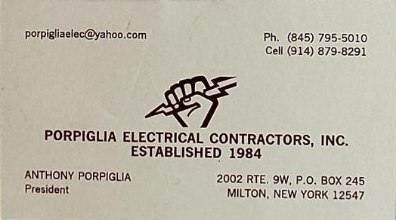
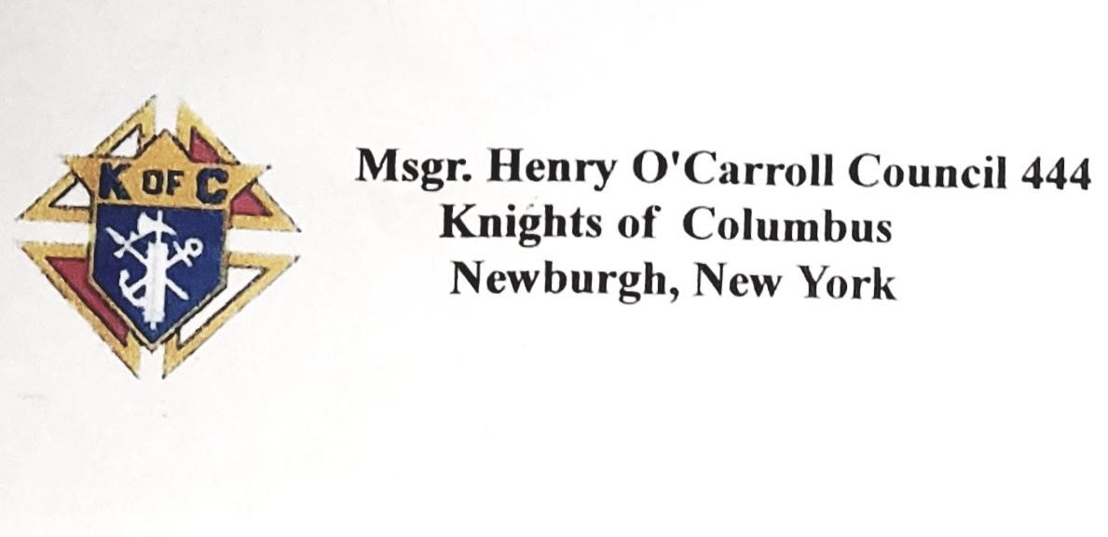 |  | 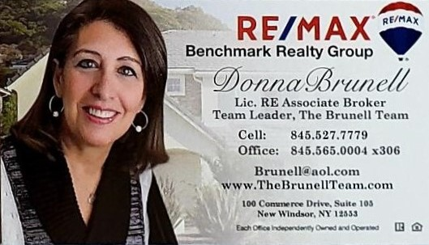
Meals On Wheels Supporters
- Apple Greens Golf Course
  - 161 South Street, Highland, NY 12528 (845) 883-5500
- Bianca Rostran, Newburgh Meals on Wheels Board of Directors
- Classic Cuts
  - 339 Blooming Grove Tpke, New Windsor, NY 12553 (845) 561-3613
- Faye Canfield, Newburgh Meals on Wheels Board of Directors
- The Country Club at Otterkill
  - 100 Otter Road, Campbell Hall, NY 10916 (845) 427-2020
- Hudson Harmony Soaps
  - www.HudsonHarmony.com (845) 728-4320
- Hudson Valley Renegades
  - 1500 Rt 9-D, Wappingers Falls, NY 12590 (845) 838-0094
- J & F Restaurant Inc
  - 474 Broadway, Newburgh, NY 12550 (845) 565-3430
- Janet Reistad, Newburgh, NY
- Joe Dirago, Newburgh Meals on Wheels Board of Directors
- Martin Sheffield, Newburgh Meals on Wheels Board of Directors
- Mona Sodano, Newburgh Meals on Wheels Board of Directors
- New Paltz Golf Course
  - 215 Huguenot Street, New Paltz, NY 12561 (845) 255-8282
- New York Football Giants
  - 1925 Giants Drive East Rutherford, NJ 07073 Phone: (201) 935-8222
- New York Jets
  - 1 Jets Drive, Florham Park, NJ 07932 Phone: (800) 469-JETS (5387)
- The Powelton Club
  - 29 Balmville Road, Newburgh, NY (845) 561-4481

Meals On Wheels Supporters (Continued)
- Price Chopper Market 32
  - 39 North Plank Road, Newburgh, NY (845) 569-2620
- Richard Mayfield, Newburgh Meals on Wheels Board of Directors
- Shawangunk Country Club
  - 38 Country Club Road, Ellenville, NY 12428 (845) 255-8282
- Storm King Golf Club & Tavern
  - 18 Ridge Road, Cornwall, NY 12518 (845) 255-8282
- Twaalfskill Golf Club
  - 282 West O'Reilly St, Kingston, NY 12401 (845) 331-5577
- Union Square Restaurant
  - 93 Route 17K, Newburgh, NY 12550 (845) 567-3800
- Winding Hills Golf Course
  - 1847 Route 17K, Montgomery, NY 12549 (845) 457-3187

Meals on Wheels “Take a Swing at Hunger” Golf Classic Committee
To make an event like today possible, it takes a lot of folks that believe in the mission of Meals on Wheels of Greater Newburgh. This includes the Sponsors, our Supporters, the golf participants, our event volunteers, the Board of Directors and our host, Storm King Golf Club and Tavern.

The “Take a Swing at Hunger” Golf Classic Committee sincerely appreciates all the parties involved to make today’s event a success. Thank you to one and all for your efforts!

- Joe Dirago, Director
- John DeLessio
- Wilbur Higgins
- Darlene Price
- Bianca Rostran
- Martin Sheffield

Volunteer – Join Our Team!
Can you help deliver nutritious meals to homebound individuals in Newburgh and New Windsor on a weekday from 11 AM until 12 noon? Each delivery route has two volunteers - one drives while the other brings the meals to the clients' door. We also need volunteers to help in our kitchen on weekdays from 9 am until 11 am and assist the cooks with preparing the meals for delivery. We will work with your schedule!
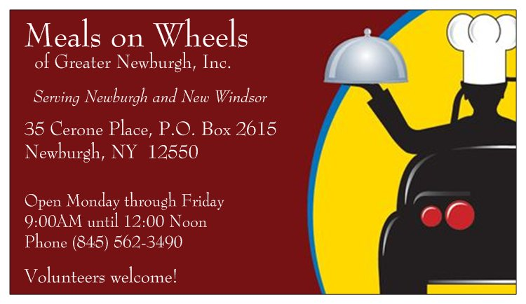
Donor Information
Meals on Wheels of Greater Newburgh is a registered 501(c)(3) charity and all donations are tax-deductible to the full extent allowed by law. To make a donation, go to https://www.mealsonwheelsnewburgh.org and click on the DONATE tab. If you prefer, you may mail your donation check to Meals on Wheels, P.O. Box 2615, Newburgh, NY 12550.
